28.65: a) Recall for a single loop: 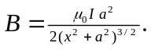Here we have two loops, each of turns, and measuring the field along the x-axis from between them means that the 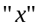in the formula is different for each case:
Left coil: 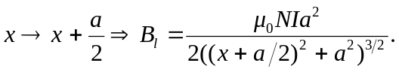
Right coil: 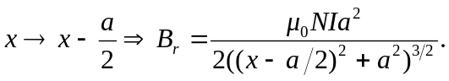

So the total field at a point x from the point between them is:
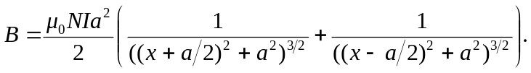

b) Below left: Total magnetic field. Below right: Magnetic field from right coil.

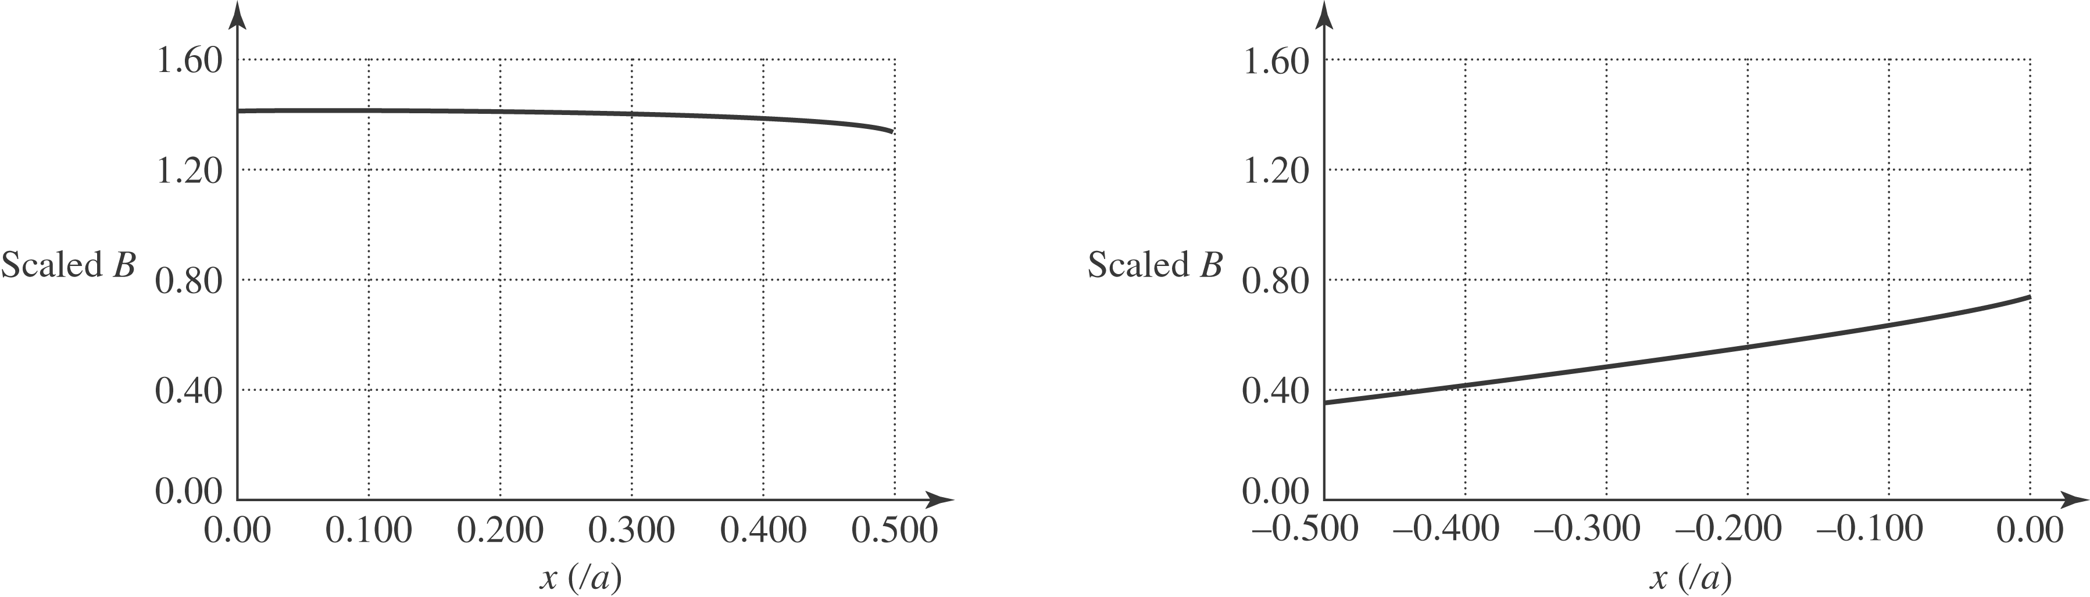

c) At point 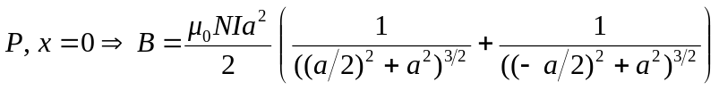
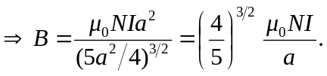
d) 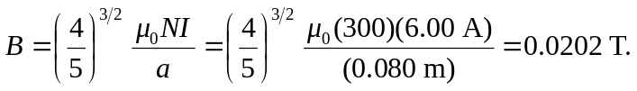
e) 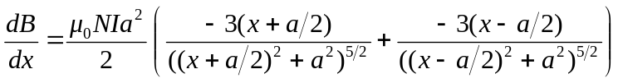
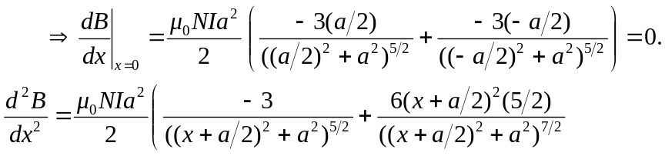

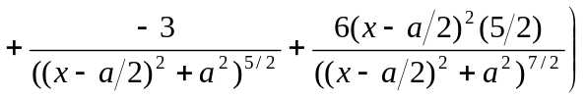
Since both first and second derivatives are zero, the field can only be changing very slowly.

